Youth
Sponsorship
Program
Kirtland, AFB

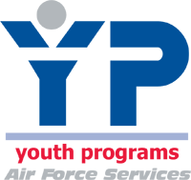

Future Open Rec Member/Families,

We are excited that you will be joining us at Kirtland, AFB! We have a terrific Youth Center with awesome programs, staff, and youth! We know you will have fun and make a lot of new friends while you are here. We have plenty to offer youth ages 5-18. Our program is affiliated with the Boys and Girls Club of America, 4-H, and the National Alliance for Youth Sports. In addition to our Youth Center, the base has a bowling alley, outdoor and indoor swimming pools, an archery range, trips and climbing wall opportunities through Outdoor Recreation, and many other recreational activities. On base we have one elementary school. All middle schools and high schools are located off base. For more information on the base and local area, please refer to the rest of this packet!
Take time to check us out… https://kirtlandforcesupport.com/

We wish you and your family a safe and enjoyable trip to Kirtland AFB in Albuquerque, New Mexico and look forward to meeting you! Please call us as soon as you arrive so that we can get you started in enjoying the fun at the Youth Center has to offer!
Ways to contact us:
Phone: 505 853 KIDS (5437)
Director: Larri Lynn Torres
larri.torres@us.af.mil
505-846-9008
Recreation
Specialists: Lucy Burbach
lucille.burbach@us.af.mil
505-846-2042
Sadie Holguin-Burciaga
sadie.holguin-burciaga.1@us.af.mil
505-846-1829
Sincerely,
Kirtland Youth Programs Staff
Request for a Pen Pal/Youth Sponsorship
So….you’re moving! Are you nervous? Scared? Excited? Would you like to communicate with someone your age with interests? Want to find out what you can expect when you arrive?
Let us know. Take a few minutes and tell us about yourself by completing this form. Please email:
Ms. Lucy @ lucille.burbach@us.af.mil and Ms. Sadie @ sadie.holguin-burciaga.1@us.af.mil
Name: _______________________________________________________________Age:_______Grade:_______
Mailing Address: ______________________________________________________________________________
______________________________________________________________________________
____________________________
Email Address: Youth__________________________________________________________________________ Email Address: Parent__________________________________________________________________________
Home Phone: ______________________________Cell:_______________________________________________
Parent’s work phone: __________________________________________________________________________
What is your estimated arrival to Kirtland AFB? ____________________________________
What do you like to do? Check next to any and all activities or write in your own.
___ Arts & Crafts ___ Cooking & Baking ___ Dance ___Skateboarding ___Computer Games
___ Video Games ___ Water Sports ___ Drama ___ Music ___Games ___ Writing
___ Reading ___ Movies ___ Sports ___ hanging out with friends
CLUBS ____ 4H ____Torch Club (ages 9-12) ____Keystone Club & Teen Council (ages 13-18)
____ Image Makers-Photography
Other:___________________________________________________________________________________________________________________________________________________________________________________________________________________________________________________________________________________
What type of music do you like? _________________________________________________________
What type of movies are your favorite? ___________________________________________________
Do you have questions about Kirtland Youth Programs? _______________________________________________________________________________________________________________________________________________________________________________________________________________________________________________________________________________________
What questions do have about New Mexico? __________________________________________________________________________________________________________________________________________________________________________

Parental Consent: I give my permission for my child’s name and contact information to be shared for the purpose of Kirtland AFB Youth Programs Youth Sponsorship Program.
Parent Signature: ______________________________________________________ Date: ____________________________ Printed Name: _________________________________________________________
Be a Youth Sponsor
Would you like to be a mentor to someone that is moving to Kirtland AFB? You will be their guide when it comes to the Youth Center and answer any questions they may have. If your answer is yes, then please take a few minutes to complete the information below and return it to Ms. Lucy Burbach or Ms. Sadie Holguin-Burciaga at the Youth Center!
Name: | Age: | Grade:
Mailing Address: | Email Address:
Home Phone: | Cell Phone: | Parents Work Phone:
When would you like to start?
What do you like to do? Check next to any/all of the activities listed below.
 | Arts and Crafts |  | Drama
 | Dance |  | Piano
 | Cooking |  | Writing/Poetry
 | Skateboard/Bike/Blade |  | Read
 | Computer (Games, internet, etc) |  | Hang out with friends
 | Shopping |  | Movies
 | Water Sports |  | Team/School Sports
 | Other:

Why would you like to be a Youth Sponsor?
______________________________________________________________________________________________________________________________________________________________________________________

What questions do you have about the Youth Sponsorship program?
______________________________________________________________________________________________________________________________________________________________________________________

Parental Consent: I give my consent for my child’s name and contact information, for the purpose of participating in the Youth Sponsorship Program.
______________________________________________ ________________________
Parent Signature Date
Youth on the Move!
A Handbook and Resource Guide for Military Youth
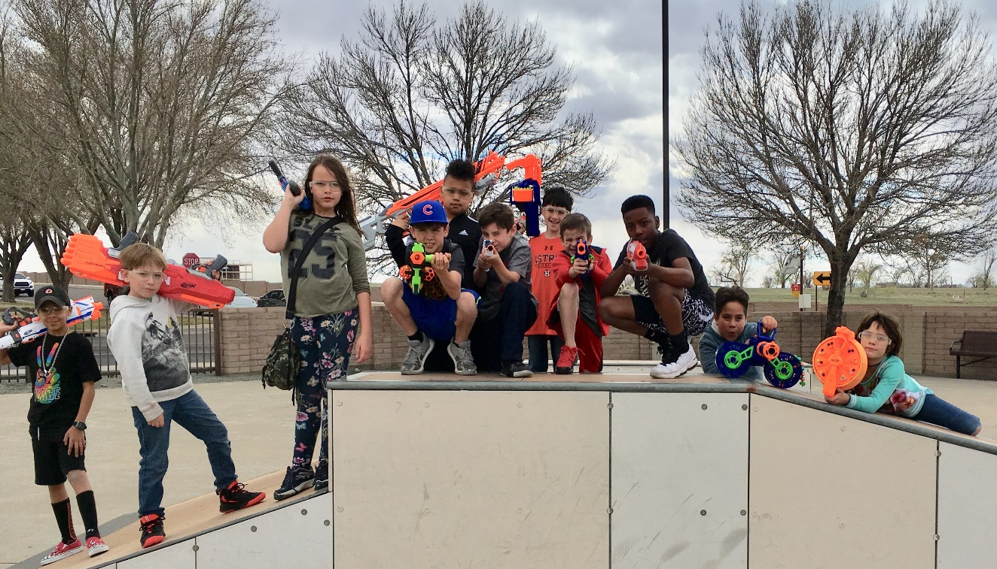

Created for you and by the Youth at Kirtland AFB

