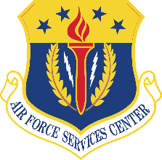
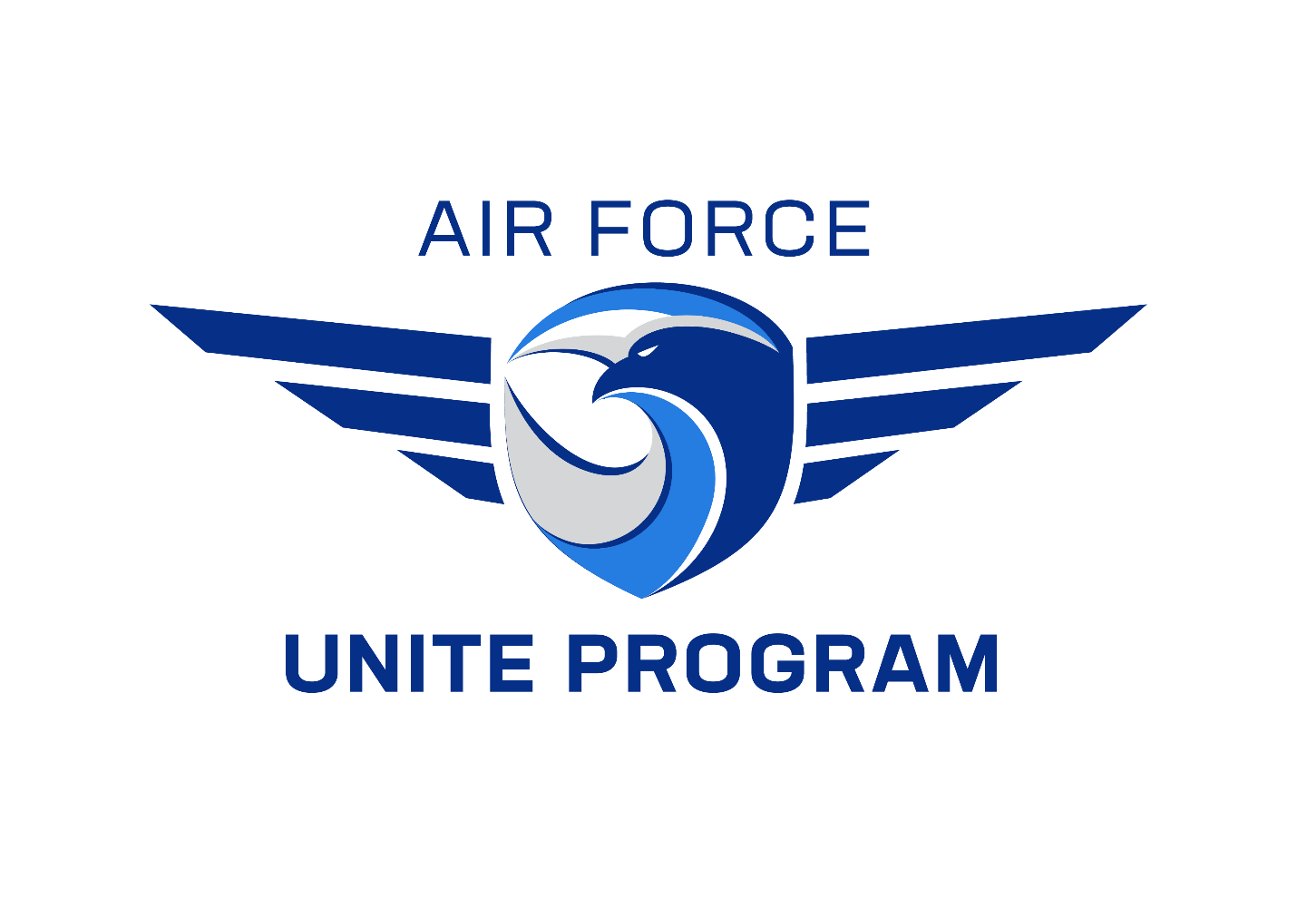
CY26 UNITE PROGRAM GUIDE

AFSVC/VCCR

2261 Hughes Ave, Suite #156

JBSA-Lackland, TX 78236

February 2026

CONTENTS
- UNITE 4
  - ROLES AND RESPONSIBILITIES 4
  - FUNDING 6
  - FOOD AND BEVERAGE 7
  - TRANSPORTATION 7
  - EQUIPMENT 8
  - TYPES OF PROGRAMS 8
  - SUBMISSION PROCESS 9
- ACCOUNTING INSTRUCTIONS FOR UNITE 10
- REFERENCES 13

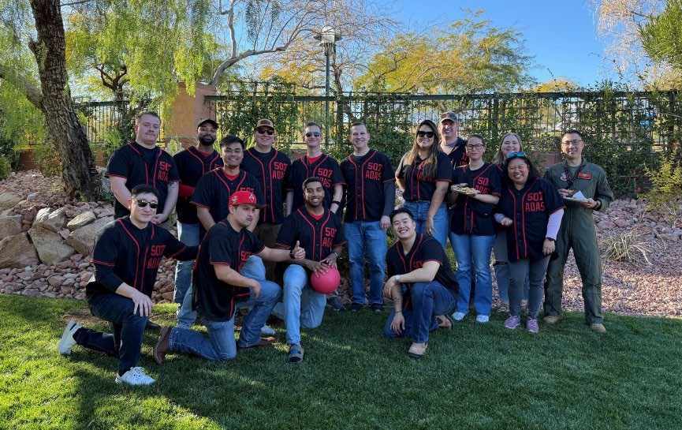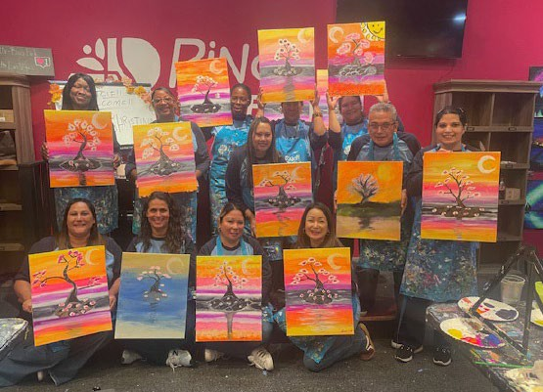
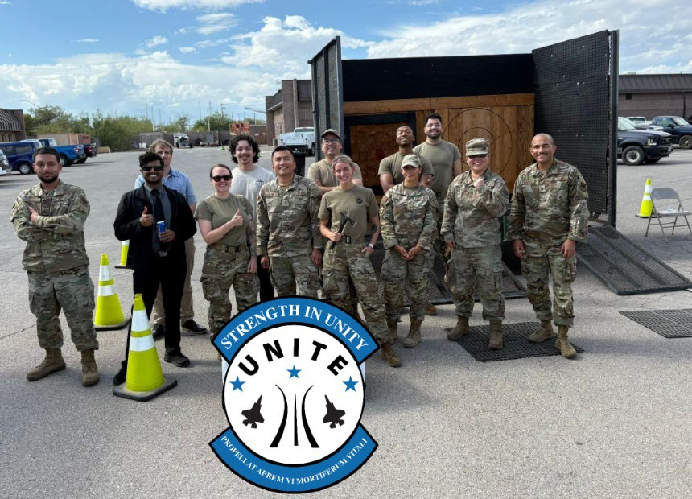
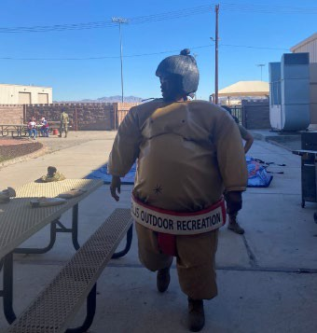
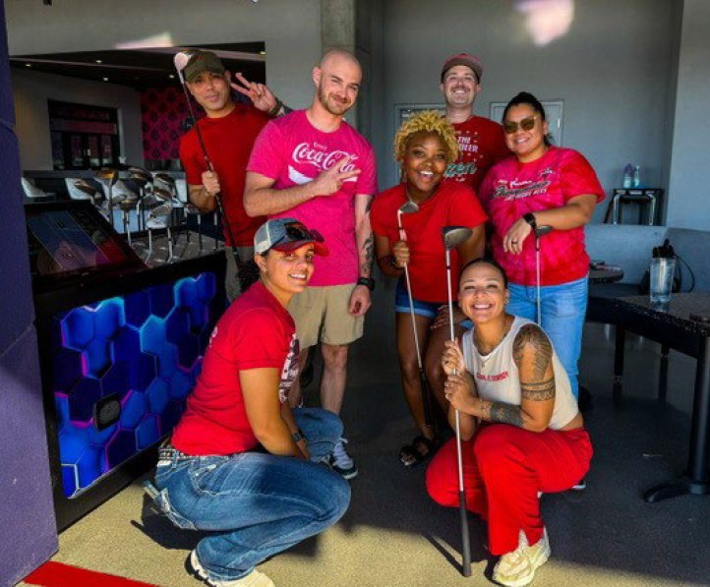
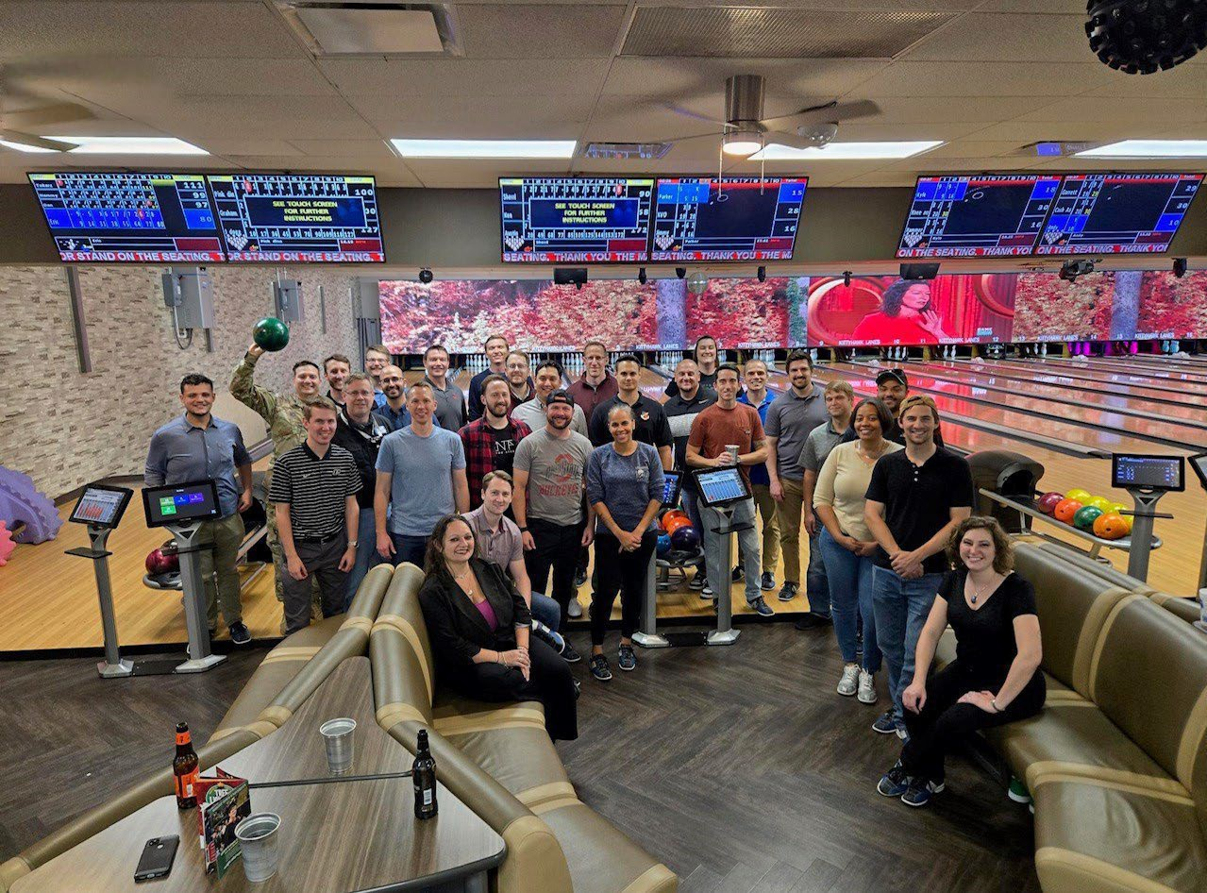

UNITE

The Unite Program empowers Squadron commanders to create new opportunities for recreational and cohesive activities to strengthen the bond between members within their unit. All Air Force and Space Force Active Duty, Reserve, Guard, and Civilian (Appropriated and Non-appropriated) members are authorized Unite funds for CY26 and their squadron will be allocated $13.50 per member in APF funding and $6.00 in NAF funding. APF dollars are provided to pay for or offset the cost of cohesive recreational activities, while NAF dollars are used for the purchase of food and beverages in support of that recreational activity.

ROLES AND RESPONSIBILITIES

UNIT COMMANDERS (CC) AND CIVILIAN LEADERS (CL):
    - Plan programs that contribute to unit cohesion and encourage squadron personnel to participate.
    - Ensure funds are expensed following established guidelines; AFIs, CONOPS, and Unite Guide.
    - To the maximum extent, use FSS programs and facilities to achieve desired effects through cost savings, geographic proximity to meet squadron needs and flexibility to military missions.
    - Designate in writing the squadron points of contact (POC)s to perform Unite duties on CCs behalf.

COMMUNITY COHESION COORDINATOR (C3):
    - Installation C3 will facilitate effective funded or free programming of high-interest recreational cohesive activities, teamwork, and camaraderie (esprit de corps).
    - Installation C3 will work with squadrons to determine their needs and interests, and help develop recreational programs, and make purchases based on their priorities.
    - Installation C3 will brief all Unit Commanders and Civilian Leaders about the Unite program’s intent, guidelines, program changes, and finances. Encourage the utilization of Unite funds throughout the installation by actively promoting Unite to installation leadership.
    - Coordinate all submissions for APF and NAF dollars with AFSVC for approval of Unite events. Verify that the total amount for the event does not exceed the limit of funding per person. Must verify that the event the unit is submitting is a recreational, unit cohesion activity-based program and not an event centered on using NAF dollars only. (Example of unauthorized events: burger burn and two truths and a lie, food-eating contest, squadron luncheon with required training i.e., SAPR and/or Green Dot). Please note: Group or Wing events are allowed, however, the purpose of Unite is to strengthen the bond between members within a squadron or smaller subsets of the squadron and every effort should be made to adhere to the intent of the program.
    - Act as the liaison and work with squadron POCs to oversee program execution and adherence to the budget.
    - Assist/advise squadron Unite POCs in developing programs, whether on or off the installation.

    - Work with FSS managers to develop and bolster new and exciting activities within their program to encourage FSS activities for Unite events.
    - Ensure fiscal responsibility and adhere to all APF and NAF instructions.
    - When funding is allocated, identify all eligible units and manpower numbers for funding per person information. Organize fund allocation for each eligible squadron.
    - Submit Unite event requests for funding through the Central Programs Management System located at https://cpms.afsv.net
    - Responsible for tracking the status of a request from submission to approval and after execution.
    - After the event has been approved by AFSVC, purchase and procure products and services using a NAF Purchase Card to directly execute a Unite activity.
    - Submit event After Action Report (AAR) after expenditure reports are completed by the base-level resource management team.
    - Post photos of each Unite event on the Air Force C3 Facebook Page or send to AFSVC if not on Facebook after the event.
    - Ensure proper documentation (event receipts, approval email, and signed event request forms) is submitted monthly to the Resource Management Flight Chief. This effort will ensure that the NAF Approving Official can complete the Expense Report for reimbursement by the 10th of every month. Reports are completed by the Resource Manager (RM) electronically at https://cpms.afsv.net.
    - Actively participate in AFSVC led training. All new C3s are encouraged to request one-on-one training via the Unite organizational box (AFSVA.SVPCL.UniteProgram@us.af.mil) and/or attend scheduled virtual training. Registration dates for any training will be announced through the AFSVC Unite team via the Community Services Flight Chiefs (or their proxy).

FSS RESOURCE MANAGER RESPONSIBILITIES:
    - Collaborate with the C3 and submit expenditure reports via https://cpms.afsv.net for installation reimbursement. The installation’s C3 properly accounts for receipt and distribution of all MOA (APF) and non-MOA (NAF) funding involving AFSVC and the installation’s squadrons.
    - Ensure the installation’s C3 provides proper documentation requesting reimbursement event receipts, approval email, and signed event request forms.
    - RMs will certify monthly financial statements. Before approving the installation's MWRF, the RM will verify the GLAC 1140000. See detailed Unite GLAC instructions in Section VI “Accounting Instructions” on page 10 of this guide.

FUNDING

FUNDS FOR THE RECREATIONAL ACTIVITIES (APPROPRIATED MOA FUNDS)
APF dollars are designated to pay for or offset the cost of cohesive recreational programs and services. Funds are allocated on a calendar year. Squadron Commanders can authorize spouses and dependents to receive the allocated per person amount. However, the APF dollar allocation will continue to be based on official manpower totals and will not increase with the inclusion of dependents. Squadrons are authorized to spend no more than $15 for every individual attending a unite event.

FUNDS FOR FOOD AND BEVERAGE (NON-APPROPRIATED FUNDS)
NAF dollars are used for the purchase of food and beverages in support of Unite recreational cohesive programs. Funds are allocated on a calendar year. The Unite program is activity-based, and NAF dollars are only an added benefit. NAF funds must be utilized in conjunction with APF dollars. Unite is not a food and beverage-based program; an event centered on just eating without a recreational and/or team building event is NOT authorized and will not be approved. Squadron Commanders can authorize spouses and dependents to be included in Unite events. However, the NAF dollar allocation will continue to be based on official manpower totals and will not increase with the inclusion of dependents.

UNAUTHORIZED USE OF UNITE FUNDS

    - Unite funds are not to be used for the following: holiday parties, end of year events, balls, banquets, dining/out, combat dining in/out, squadron training/meetings, change of commands, eating events, promotions/retirements/graduations, or base-wide special events.
    - Unite funds cannot be used to purchase alcoholic beverages.
    - Unite funds cannot be used to purchase equipment, including electronics. However, funds are authorized to rent recreational equipment in support of a unit cohesive event. Unauthorized rentals include but are not limited to portable toilets, trash services, cleaning fees, cleaning supplies or cleaning companies, and lodging. Contact AFSVC if the cost of renting equipment exceeds the cost of procuring the equipment.
    - Unite funds are not authorized to purchase items for volunteer events, such as protective gloves, tools, paint, or supplies.
    - Unite funds cannot be used to purchase cleaning supplies, hand sanitizer, etc. latex food service gloves and trash bags are authorized.
    - Unite funds cannot be used to cover the cost of damages, late fees, or insurance.
    - Unite funds cannot be used to purchase prizes, gift cards (to include digital), giveaways, or promotional items. (Examples include trophies, medals, plaques, banners, marketing/advertisements, apparel, cups, personalization of objects, murals, shirts, hats, jerseys, etc.)

    - Unite funds cannot be used to purchase equipment to donate to charities (Example: Build-A-Bed and Build-A-Bike).
    - Unite funds cannot be used for gambling or to purchase gambling products, including traditional bingo games, where funds are accumulated and paid to a winner. Such an arrangement is a prohibited practice that conveys personal benefit to a winner.
    - Decorations for Unite events should not exceed more than 10% of the event's total cost. (Example: squadron teambuilding event cost $1000, then the cost of decorations should not exceed $100).
    - AFSVC will not provide reimbursement to events that have not been approved. If a squadron executes an event without approval, all expenses will be the responsibility of the squadron.
    - Commanders should make every effort to ensure all authorized members of a unit have an opportunity to participate in Unite events; inclusive to all Airmen and Guardians in a unit and cannot be divided based on age, race, gender, or religion. A Unite event cannot be held for dependents only.
    - Wing or Group events may be held with written agreement from each participating Unit Commander for the use of their funding. During multi-day events, each squadron must have a specific time to participate in activities, which should also be detailed within the submission. Remember, the purpose of Unite is to strengthen the bond between members within a squadron or smaller subsets of the squadron.
NOTE: APF dollars are intended to fund the actual team-building event only.

FOOD AND BEVERAGE
AFSVC will provide centrally funded NAFs ($6.00 per person) to subsidize meals in conjunction with approved Unite cohesive activities. The C3 will coordinate with FSS food activities when possible. (i.e., club, bowling center, golf course and snack bar operations, etc.)

TRANSPORTATION
Unite funds are not authorized to pay for rental vehicles; utilizing ITT/ODR vehicles with a driver is authorized.

EQUIPMENT
Unite funds are not authorized to pay for equipment purchases. APF funds can be used to rent equipment for the approved event (i.e., FSS equipment rental through ODR).

TYPES OF PROGRAMS
The Unite Program intends to provide unit leaders with the maximum flexibility to develop and deliver recreational programs to build cohesion for personnel within their unit, or subset of the unit, to include spouses and dependents at their discretion. Installation C3s provide squadron leaders with program ideas that are authorized uses of Unite funds. Squadron leaders are given the discretion to create Unit-Developed Programs (UDP) that capitalize on opportunities available in the geographic area. C3s are encouraged to offer volunteer and no-cost programs in addition to UDPs. Events must be both recreational and unit cohesive to utilize Unite funds. All programs must be submitted to AFSVC for approval at least seven business days before the event date.

SAMPLES
UNIT-DEVELOPED | VOLUNTEER /FREE | VIRTUAL
Bowling Axe Throwing  Squadron Fun Day  Golf/Top Golf | Food Bank Highway Cleanup Squadron Fun Run  Unit/Squadron Olympics | Teambuilding.com Teambonding.com Wildly Different  Virtual 5K

SUBMISSION PROCESS
Step 1. Meet with squadron POC to select and develop a unit cohesive program. Provide an event request form to squadron POC. Inform the POC they are responsible for getting prices, quantity, and description of purchases for squadron events.
Step 2. POC will return the event request form signed by the Squadron Commander to the C3. Note: The Squadron Commander's signature acknowledges that they are aware of the event and

how their allocations are being spent. The POC will provide a detailed cost breakdown of how funds will be paid.
Step 3. C3 will submit requests through the CPMS at https://cpms.afsv.net. Select the "Submit Unite Funding Request", the "Request Form" should be the default screen. If not, then click "Request Form" from the top menu options. Once the form is complete, scroll down and select “Submit”. The CPMS will then provide a tracking ID for your program request submission. If you do not receive a tracking ID, then the database has not accepted your form. NOTE: If you do not already have a profile, click “If you need to request access, please click here”.
Step 4. Check on your submission until approval is confirmed in the database. If your request is "Declined" or "Returned for Modification" there will be feedback on the submission to clarify. Once a "Returned for Modification" submission is updated by the C3, the status will change to "New" placing it back on AFSVCs radar for approval review. If an "Approved" submission is updated by a C3, the status will change to "New" meaning it will have to be re-reviewed for approval. At the time a submission reverts to "New" status, the seven-business day cycle begins anew. NOTE: Last day for submission adjustments is 5 January (2359 CST) 2027.
Step 5. Once the event is approved, the C3 will pay for event expenses with the P-Card (observing 889 requirements) and the squadron will proceed with their activity.

NOTE: Unite funding for room rentals will max at $500. Unite funding for DJs will max at $500. NOTE: Members may not profit from vendor services provided during their squadron's Unite event(s).
Step 6. After the event, coordinate delivery of receipts and backup documentation to the installation NAF Accounting Office (AO) to allow them to complete expenditure reports (ERs) at
https://cpms.afsv.net to submit reimbursement for all incurred/approved expenses.
Step 7. Complete an After-Action Report (AAR) within 10 days of the event at https://
cpms.afsv.net to detail the success and learning points. This will serve as a reminder for you, or as guidance for the C3 that takes the role once you depart. If the APF/NAF dollar amounts do not match your records, discuss the discrepancy with the Accounting Office.
Step 8. Photos are essential to support continued funding each year. Post photos of the event onto the Air Force C3 Facebook page or send to AFSVC after the event (AFSVA.SVPCL.UniteProgram@us.af.mil).

NOTE: AFSVC’s goal is to review requests within seven business days of the installation’s submission.

ACCOUNTING INSTRUCTIONS FOR UNITE

PROGRAM EXPENSES
- Installations record all expenses incurred under the program to Activity XXX46 / Cost Center (CC)1520 APF-MOA / CC 1521 NAF Non-MOA.
  - Lines of Accounting (LOA):

APF-MOA: XXX46.001.XXXX.1520.1140000
NAF Non-MOA: XXX46.001.XXXX.1521.1140000

- Installations utilizing base activities for events:
  - Activity will record income on AF 1876, NAF Consolidated Cost Center Report:
Debit Credit
1140000 – NAFI Receivable XXX
3010000/5010000 – Sales/Fees and Charges XXX
  - NAF AO will process a General Ledger Adjustment Form (GLAF) to reclassify accounts receivable, credit GLAC 1140000 and debit GLAC 1140016 to the respective cost center 1520 or 1521.

RECORDING RECEIPT OF FUNDS
- Installation NAF Accounting Offices record receipt of Unite program MOA and non-MOA funds from AFSVC as follows:
Debit Credit
XXXXX.001.0000.0000.1140016 XXX
XXX01.000.XXXX.1520.1140000 (MOA) XXX
XXX01.001.XXXX.1521.1140000 (NAF Non-MOA) XXX

PER CAPITA PAYMENTS
- INSTALLATION PER CAPITA PAYMENTS TO SQUADRONS VIA NAF PURCHASE CARD:
NAF Purchase Card payments will be reallocated to the above MOA line of accounting (non-food) and the above non- MOA line of accounting (food) for approved Unite expenditures. The NAF Purchase Card is the preferred method of payment for purchases. The Single Purchase Limit (SPL) of $15,000 must be strictly adhered to by all cardholders. However, upon written authorization (completed award) from a warranted contract officer, a cardholder may use it as a payment method for a completed award. Each transaction must be reviewed & approved in the online banking software (Payment-Net) within three (3) business days of the post date (three days for C3 review, and one day for Approver review).

Documentation within Payment-Net will include the following:

Transaction Notes: Clearly state “what” was purchased and “why.”
“Award no.” field if the transaction is greater than $10,000.

- INSTALLATIONS’ PER CAPITA PAYMENTS TO SQUADRONS VIA CHECK:
The FSS NAF Accounting Office (NAF AO) can request a check to pay for an approved event if the activity cannot utilize the Purchase Card. The check will be sent to the NAF AO for distribution to the requesting unit/squadron. Checks can be presented to either the unit/squadron bank or any local Chase Bank for conversion to cash (please ensure you have access to one of the two above options before requesting a check).
  - The installation's C3 will prepare a NAF Disbursement Request (DR) and submit it to the NAF AO when requesting a check. Please allow ample time for requesting and receiving the physical check. Allow the AFSVC three (3) business days for processing check requests once the DR is submitted. The standard time for CONUS mail delivery is five (5) business days. This delivery time will be longer for OCONUS locations.
  - DR Notes: The unit/squadron needs to identify two individuals as payees when requesting a check (but only one will need to be present when cashing the check). Ensure the following information is placed in the Comments section of the completed DR.

PAY VIA CHECK
First Line: Full Name of 1st or 2nd POC
Second Line: Petty Cash
Third Line: Address for mailing check
*Do not use the word "and"

  - Accounting Instructions for Checks Issued:
DR: See Debit Line of Accounting (LOA) above for the MOA LOA for non-food items or Non-MOA LOA for food items.
CR: GLAC 2010000 – Vendor Accounts Payable.

EXPENDITURE REPORTS
- The installations' NAF AOs will record Unite expenditures on the Monthly NAF AO Expenditure Report (ER). Submit only the reimbursable expenses for previously approved request(s) for the period reported. To avoid errors in reimbursement, do not carry over expenses or balances from prior months, and record expenses on the ER as they are incurred. Submit the reports monthly, as requested, to avoid missing a reimbursement opportunity. ERs received after the firm cutoff date of Friday, 15 January (2359 CST) 2027; are not guaranteed to be processed for reimbursement.
6.1 Please follow the steps below to submit ERs:

Step 1. Go to https://cpms.afsv.net, and click “Submit Unite Funding Request”, then select “NAF AO Expenditure Report” from the menu at the top of the page.

Step 2. Select your installation, year, and reporting month from the drop-down menu.
Step 3. Enter a new expense item by selecting the appropriate program line from the [CY25– Unite Requests] drop-down options. All fields must match the request number (tracking ID) relating to the expenditure line item(s).
Step 4. Click “Save New Expense Line.”
Step 5. Repeat steps 3 and 4 until all expenditure line items have been entered and saved.
Step 6. Once the NAF AO verifies the expense line items entered are correct, scroll down to click on the paper icon that states "IMPORTANT" to finalize expenses, and generate the monthly ER.
Step 7. This effort will create a web-based ER that must be approved/signed by the Resource Manager (RM). The action of Step 6 automatically sends an email notification to all listed NAF AO POCs, which will include a link to the web-based ER.
Step 8. The RM or designee digitally signs the web-based ER, automatically emailing AFSVC/VFAA a file, which will include your installation's name, "Unite," and also reflects the “As Of" month and year; shown on the ER (Ex: JBSA-Lackland-Unite-Feb26.) The RM or designee must differ
from the Requestor and the Submitter to satisfy separation-of-duty requirements. RM or designee must submit documentation assigning designee to AFSVC/VFAA via email memo to AFSVA.FMNFA@us.af.mil.

Step 9. The installation is responsible for confirming receipt of reimbursement and ensuring the amount matches the expenditure report sent to the AFSVC. For any variance, it is the installation’s responsibility to research to find the error and work with the AFSVC to resolve it. Any unreconciled variances should be posted to GLAC 7890000 for the current year. Any prior year variances should be posted to GLAC 9120000.

POINTS OF CONTACT
Reimbursement status inquiries or expenditure report concerns should be sent to the AFSVC Central Funding org box: AFSVA.FMNFA@us.af.mil All other Unite business should be directed to this address
- AFSVA.SVPCL.UniteProgram@us.af.mil with your installation in the subject line.

REFERENCES
DoDI 1015.10, Military Morale, Welfare, and Recreation (MWR) Programs

DAFI 34-101, Air Force Morale, Welfare, and Recreation (MWR) Programs and Use Eligibility

DAFI 65-106, Appropriated Fund Support of Morale, Welfare, and Recreation (MWR) and Non-Appropriated Fund Instrumentalities (NAFIs)

DAFI 65-601 V1, Budget Guidance and Procedures

DAFMAN 34-201, Use of Non-Appropriated Funds (NAF)

DAFMAN 34-202, Procedures for Protecting Non-Appropriated Funds Assets

DAFMAN 34-209, Non-Appropriated Fund (NAF) Financial Management and Accounting

DAFMAN 64-119, Non-Appropriated Fund (NAF) Contracting Procedure

DAFI 38-101, Manpower and Organization

